1. A central atom bonded to two other atoms and having no lone electron pairs would be expected to have a bond angle of a) 90o b) 120o c) 109o d) 180o e) 60o

2. Which set consists entirely of molecules that would exhibit **no** hydrogen bonding?

a) PH3 , HCl, N2H4 b)OF2, HF, IF3 c) H2O, NH3, CH3OH

d) CH4, H2Se , BeH2

3. Which exhibits resonance, or delocalization of π bonds? a) N2 b) NO2-

c) C2H2 d) CH3CH=CHCH3 e) H2S



4. In the compound shown to the right,

what type(s) of hybridization are assigned to the carbon? a) sp3 only b) sp3 and sp2

c) sp3 and sp d) sp2 and sp e) sp2 only

Questions 5 to 10 use the following choices:

A) Linear B) Bent C) Trigonal Pyramid D) Trigonal Planar E) Tetrahedral

What is the geometry of each of the following molecules and ions?

5. BCl3 6. PF3 7. NO3— 8. NH4+ 9. SO2 10. HCN

11. Which has a dipole moment of zero? A) NO B) SO2 C) NH3 D) C6H6 (benzene)

E) H2S

12. The Lewis structure of which of the following molecules shows only one unshared (lone)

pair of valence electrons? A) Cl2 B) N2 C) NH3 D) CCl4

13. Which of the following has the greatest dipole moment? A) CH3Cl

B) BCl3 C) CO2 D) SO3

14. Which of these has a square planar shape? A) ICl4— B) SF4 C) NH4+ D) CH3Cl

15. The electron pair geometry of the ion NO2+  is A) triangular B) bent

C) linear D) tetrahedral E) octahedral.

16. When the reaction C2H2(g) + Cl2(g) ⭢ C2H2Cl2(g) occurs, does the hybridization of the carbon atoms change? A) Yes, from sp to sp2 B) yes, from sp to sp3

C) yes, from sp2 to sp3 D) No, it does not change.

17. 2 H2O2 (aq) ⭢ 2 H2O (*l*) + O2(g) ΔH° = − 196 kJ/mol

Assume that the bond enthalpies all of the O-H bonds are the same. Based on the value of ΔH° for the reaction provided above, which set of bond energies are possible? (in kJ/mol)

O−O O=O O−H

in H2O2 in O2

______________ ___________ ___________

A) 300 500 500

B) 150 500 500

C) 500 300 150

D) 200 300 150

18 -21. Match the hybridization with that of the central atom in each of the following:

molecules and ions.

A) sp3 B) sp2 C) sp

18. NCl2F (the nitrogen is central)

19. SO2

20. HCN

21. SO3

22. A cuvette containing a 0.40 molar solution of CuSO4 ( which is blue) is placed in a

spectrophotometer, set at 635 nm. It shows an absorbance of 0.60. A cuvette containing a solution of CuSO4 of unknown concentration in the same spectrophotometer, at the same wave length, has an absorbance of 0.15. What is the concentration of the unknown?

A) 0.10 M B) 0.20 M C) 0. 25 M D) 1.6 M

23. A pi bond is A) concentrated along the internuclear axis B) formed by the side to side

overlap of p orbitals C) formed by sp2 orbitals D) formed by the side to side overlap of sp3 orbitals

24. A sigma bond is A) concentrated along the internuclear axis B) formed by s orbitals only C) formed by p orbitals only D) concentrated above and below the internuclear axis.

25 to 27. Choices: A) London forces B) Hydrogen bonding C) non-polar covalent bonding

D) polar covalent bonding E) ionic bonding.

25. Explains why Xenon has a higher boiling point than Neon

26. Explains why alcohols, such as C2H5OH are liquids, while similarly sized hydrocarbons are

gases at room temperature.

27. The bonding between the carbon and the oxygen in carbon dioxide.

28. Which of the following ionic crystals has the greatest lattice energy?

A) KI B) NaBr C) MgO D) MgCl2

29. How many resonance structures are possible for the SO3 molecule?

A) none B) 2 C) 3 D) 4 E) 6

30. Which bond angle is LEAST likely in any simple molecule ?

A) 60o B) 109o C) 120o D) 90o E) 180o

31. Which of the following is predicted to have the largest bond angle?

A) H2O B) NH3 C) BH3 D) CH4 E) SiH4

Essays: Answer Questions I and II, plus two others, for a total of 4 essays. You may do a fifth one for extra credit.

I. a) Consider the carbon dioxide molecule, CO2 , and the carbonate ion, CO32—.

1) Draw complete Lewis electron dot diagrams for each species.

2) Compare the carbon-oxygen bond length in the two species, and explain any difference.

b) Consider the molecules CF4 and SF4 .

1) Draw the complete Lewis electron dot diagram for each molecule.

2) State whether each molecule is polar or nonpolar, and briefly explain your decision.

II. Structures of the dimethyl ether and ethanol molecules are shown below. The normal boiling point of dimethyl ether is 250 K, while the normal boiling point of ethanol is 351 K. Account for the difference in boiling points. You must discuss BOTH of the substances in your answer.

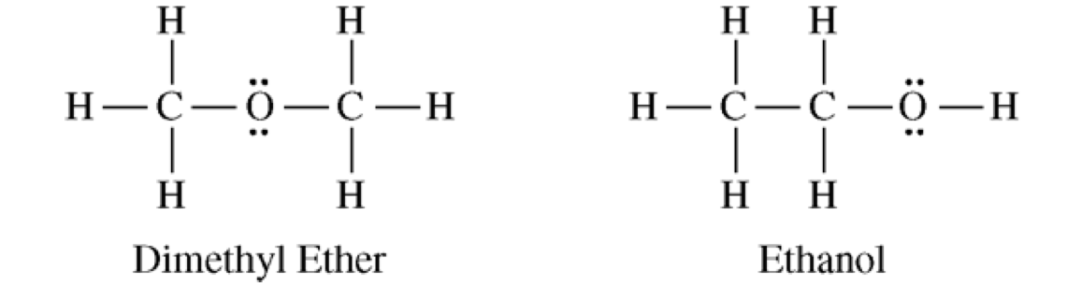

B. The normal boiling point of Cl2(*l*), 238 K, is **higher** than the normal boiling point of HCl(*l*).

(188 K) Account for the differences in normal boiling points based on the types of intermolecular forces in the substances. You must discuss **both** substances in your answer.

C. Xenon can react with oxygen and fluorine to form compounds such as XeO3 and XeF4 .

1. Draw the complete Lewis electron-dot diagram for each of these two molecules.

2. On the basis of the electron dot diagrams you drew for part 1, predict the following:

a) The geometric shape of the XeO3 molecule

b) The geometric shape of the XiF4 molecule

c ) Predict whether the XeO3 molecule is polar or nonpolar. Justify your prediction.

III. Consider the molecules PF3 and PF5

a) Draw the Lewis electron dot structures of both molecules, and predict the molecular

geometry of each.

b) State whether each molecule is polar or nonpolar, and explain your answer.

c) Explain why PF5 exists, but NF5 does not.

d) Which is likely to have a higher boiling point - KCl or NaF? Explain

IV. A. Draw the structure of the sulfite ion, SO32— .

1) Find the formal charge on each atom in the structure you have drawn.

2) Indicate the geometry of the ion.

3) Which of the following bond angles are most likely for this ion? Explain your choice

a) 120o or b) 118o or c) 109o or d) 107o

V. Draw Lewis structures for each of the following species. In each case, indicate the total

number of sigma bonds, and the total number of pi bonds in the molecule or ion.

A) COCl2 B) C3H4 C) C2O42— D) HNO2