Name_______________________

1 In basic solution, __________.
A) [H3O+] = [OH-] B) [H3O+] > [OH-] C) [H3O+] < [OH-] D) [H3O+] = 0 M

2) The hydride ion, H-, is a stronger base than the hydroxide ion, OH-. The product(s) of the reaction of hydride ion with water is/ are __________.
A) H3O+ (aq) B) OH- (aq) + H2 (g) C) OH- (aq) + 2H+ (aq) D) H2O2 (aq)

3) Of the following, __________ is a weak acid.
A) HF B) HCl C) HBr D) HNO3 E) HClO4

4. The Ka of hypochlorous acid (HClO) is 3.0 × 10-8 at 25.0°C. What is the % ionization of hypochlorous acid in a 0.015 M aqueous solution of HClO at 25.0°C?
A) 4.5 × 10-8 B) 1.4 × 10-3 C) 2.1 × 10-5 D) 0.14

5. Using the data in the table, which of the conjugate bases below is the weakest base?

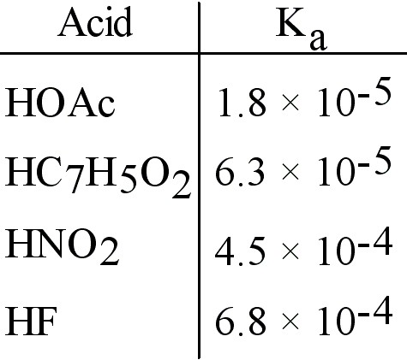
A) OAc- B) C7H5O2- C) NO2- D) F-

6. A 0.0035 M aqueous solution of a particular compound has pH = 2.46. The compound is A) a weak base B) a weak acid C) a strong acid D) a strong base

7) A 0.1 M solution of __________ has a pH of 7.0.
A) Na2S B) KF C) NaNO3 D) NH4Cl

8. The conjugate base of H2PO4- is __________.
A) PO4-3 B) H2PO4 C) H3PO4 D) HPO4-2

9. HZ is a weak acid. An aqueous solution of HZ is prepared by dissolving 0.020 mol of HZ in sufficient water to yield 1.0 L of solution. The pH of the solution was 4.93 at 25.0°C. The Ka of HZ is __________.
A) 1.2 × 10-5 B) 6.9 × 10-9 C) 1.4 × 10-10 D) 9.9 × 10-2

10. A 0.15 M aqueous solution of the weak base B at 25.0°C has a pH of 8.88. The value of Kb for B is __________.
A) 3.0 × 10-5 B) 1.8 × 10-5 C) 3.9 × 10-10 D) 1.3 × 10-10

11. The base-dissociation constant, Kb, for pyridine, C5H5N, is 1.4 × 10-9. The acid-dissociation constant, Ka, for the pyridinium ion, C5H5NH+, is __________.
A) 1.4 × 10-23 B) 7.1 × 10-4 C) 1.4 × 10-5 D) 7.1 × 10-6

12. The pH of a 0.15 M aqueous solution of NaZ (the sodium salt of HZ) is 10.7. What is the Ka for HZ?
A) 1.6 × 10-6 B) 6.0 × 10-9 C) 8.9 × 10-4 D) 1.3 × 10-12

13. The reaction HSO₄⁻ (aq) + H₂PO₄⁻ (aq) → SO₄²⁻ (aq) + H₃PO₄ (aq) has an equilibrium constant that is greater than 1. Based on this information we can conclude that
A) H₃PO₄ is a stronger acid than HSO₄⁻
B) HPO₄²⁻ is a stronger base than SO₄²⁻
C) SO₄²⁻ is a stronger base than H₂PO₄⁻
D) HSO₄⁻ is a stronger acid than H₃O⁺

14. A solution containing which one of the following pairs of substances will be a buffer solution? A) NaI, HI B) KBr, HBr C) RbCl, HCl D) CsF, HF

15) What change will be caused by addition of a small amount of HCl to a solution containing fluoride ions and hydrogen fluoride?
A) The concentration of hydroxide ions will increase significantly.
B) The concentration of fluoride ions will increase as will the concentration of hydronium ions.
C) The concentration of hydrogen fluoride will decrease and the concentration of fluoride ions will increase.
D) The concentration of fluoride ion will decrease and the concentration of hydrogen fluoride will increase.

16. The addition of hydrofluoric acid and __________ to water produces a buffer solution.
A) HCl B) NaNO3 C) NaCl D) NaOH

17. The concentration of iodide ions in a saturated solution of lead (II) iodide is ___ M. The solubility product constant of PbI2 is 1.4 × 10-8.
A) 3.8 × 10-4 B) 3.0 × 10-3 C) 1.5 × 10-3 D) 3.5 × 10-9

18. Calculate the pH of a solution that is 0.210 M in nitrous acid (HNO2) and 0.290 M in potassium nitrite (KNO2). The acid dissociation constant of nitrous acid is 4.50 × 10-4.
A) 3.487 B) 3.210 C) 13.86 D) 10.51

19. Consider a solution containing 0.100 M fluoride ions and 0.126 M hydrogen fluoride. The concentration of fluoride ions after the addition of 4.00 mL of 0.0100 M HCl to 25.0 mL of this solution is __________ M.
A) 0.0862 B) 0.0876 C) 0.0980 D) 0.0848

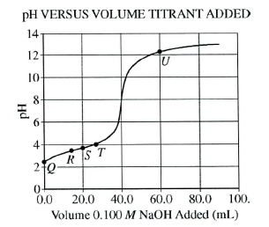
A 50.0 mL sample of an acid, HA, of unknown molarity is titrated, and the pH of the resulting solution is measured with a pH meter and graphed as a function of the volume of 0.100M NaOH added.

20. At point R in the titration, which of the following species has the highest concentration?
A) HA B) A- C) H₃O⁺ D) OH⁻

21. Which of the following is the best particulate representation of the species other than water that are present in significant concentrations in the solution at point U in the
titration?
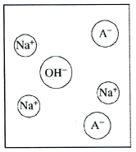
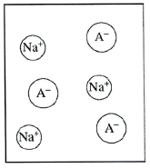

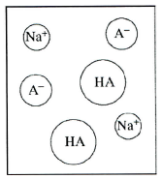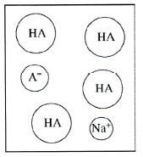
A B C D

22. At which point on the titration curve is [A⁻¹] closest to twice that of [HA]?
- R B) S C)T D) U

23. A student carries out the same titration, but uses an indicator instead of a pH meter. If the indicator changes color slightly past the equivalence point, what will the student obtain for the calculated concentration of the acid?
- Slightly less than 0.0800 M B)Slightly more than 0.0800 M
C)Slightly less than 0.125 M D)Slightly more than 0.125 M
Questions 24-28 refer to the following.

Concentration  (M) | pH of  Acid 1 | pH of  Acid 2 | pH of  Acid 3 | pH of  Acid 4
0.010 | 3.44 | 2.00 | 2.92 | 2.20
0.050 | 3.09 | 1.30 | 2.58 | 1.73
0.10 | 2.94 | 1.00 | 2.42 | 1.55
0.50 | 2.69 | 0.30 | 2.08 | 1.16
1.00 | 2.44 | 0.00 | 1.92 | 0.98

The pH of solutions of four acids prepared at various concentrations were measured and recorded in the table above. The four acids are, in no particular order, chlorous, hydrochloric, lactic and propanoic.

24. For which acid is the value of the acid-dissociation constant, K_{a}, the smallest?
- Acid 1 B)Acid 2 C)Acid 3 D)Acid 4

25. Which of the four acids listed in the table is hydrochloric acid?
A) Acid 1 B)Acid 2 C)Acid 3 D)Acid 4

26. Of the following species, which has the greatest concentration in a 1.0 M solution of acid 1 at equilibrium? A) OH⁻ B) H3O⁺ C)Acid 1 D) The conjugate base of acid 1

27) If equal volumes of the four acids at a concentration of 0.50 M are each titrated with a strong base, which will require the greatest volume of base to reach the equivalence point? A)Acid 1 b) Acid 2 C)Acid 3
D) All the acids will require the same volume of base to reach the equivalence point.

28) A 25 ml sample of a 1.0 M solution of acid 1 is mixed with 25 ml of 0.50 M NaOH. Which of the following best explains what happens to the pH of the mixture when a few drops of 1.0 M HNO₃ are added?
- The pH of the mixture increases sharply, because HNO₃ is a strong acid.
- The pH of the mixture decreases sharply, because H₃O⁺ ions were added.
- The pH of the mixture stays about the same, because the conjugate base of acid 1 reacts with the added H₃O⁺ ions.
- The pH of the mixture stays about the same, because OH⁻ ions in the solution react with the added H₃O⁺ ions.

29) In which of the following aqueous solutions would you expect PbCl2 to have the lowest solubility? A) 0.020 M KCl B) 0.020 M BaCl2 C) 0.015 M PbNO3
D) pure water

30. The Ka of acetic acid is 1.76 × 10-5. The pH of a buffer prepared by combining 45.0 mL of 1.00 M potassium acetate and 50.0 mL of 1.00 M acetic acid is __________.
A) 1.705 B) 0.851 C) 3.406 D) 4.709

31) Calculate the pH of a solution prepared by dissolving 0.850 mol of NH3 and 0.350 mol of NH4Cl in water sufficient to yield 1.00 L of solution. The Kb of ammonia is 1.77 × 10-5.
A) 5.137 B) 4.367 C) 9.633 D) 8.781

32. How many milliliters of 0.120 M NaOH are required to titrate 50.0 mL of 0.0998 M butanoic acid to the equivalence point? The Ka of butanoic acid is 1.5 × 10-5.
A) 4.90 B) 50.0 C) 41.6 D) 60.1

33. The weakest of the following anion bases is A) ClO⁻ B) BrO⁻ C) BrO₃⁻
D) ClO₄⁻

FREE RESPONSE.

I. All oxyacids contain an O-H bond. The strength of that bond determines the strength of the acid.
A. What is the relationship between the strength of the O-H bond in an oxyacid, and the strength of the acid?

B. Consider acids represented by the general formula X-O-H, where X may be a single atom, or may have additional oxygens bonded to it. Explain how each of the following affects the strength of the O-H bond.

i. The electronegativity of element X.

ii. The number of O atoms bonded to element X.

II. C₆H₅NH₂(aq) + H₂O C₆H₅NH₃⁺(aq) + OH⁻(aq)

Aniline, a weak base, reacts with water as shown above.

a) Write the equilibrium constant, Kb, for the reaction shown above

b) A sample of aniline is dissolved in water to produce 25.0 mL of a 0.10 M solution The pH of the solution is 8.82 . Calculate the Kb of aniline.

c) The solution prepared in part b is titrated with 0.10 M HCl. Calculate the pH of the solution when 5.0 mL of the acid has been added.

d) Calculate the pH at the equivalence point of the titration in part c.

III.
A. At 10° C, 8.9 x 10⁻⁵ grams of AgCl(s) will dissolve in 100. mL of water.
(i) Write the equation for the dissociation of AgCl(s) in water

(II) Calculate the solubility of AgCl in water at 10° C in moles per liter

(iii) Calculate the Ksp of AgCl at 10°C.

B. At 25°C the Ksp for PbCl₂ is 1.6 x 10⁻⁵ , and the Ksp of AgCl is 1.8 x 10⁻¹⁰

(i) If 60.0 mL of 0.0400 M NaCl is added to 60.0 mL of 0.0300 M Pb(NO₃)₂ will a
precipitate form? Show calculations to support your answer.

ii) Calculate the equilibrium [Pb²⁺] in 1.00 L of saturated PbCl₂ solution to which 0.250 mole of NaCl has been added. Assume no volume change.

iii) If a 0.100 M NaCl solution is added slowly to a beaker containing both 0.120 Molar AgNO₃ and 0.150 M Pb(NO₃)₂ at 25° which will precipitate first? Show calculations to support your answer.

IV. A student is asked to find the molarity of an acetic acid solution. The Ka of that acid is 1.8 x10⁻⁵ . The student first standardizes an NaOH solution against the diprotic acid oxalic acid, H₂C₂O₄ (MM = 126) 8.05 grams of oxalic acid are dissolved, and water is added to a volume of 250.0 mL.
A. What is the molarity of the oxalic acid solution that was prepared?

B. The acid is used to titrate the NaOH solution. On average, 42.0 mL of the NaOH solution are required to neutralize 40.0 mL of the oxalic acid solution. What is the molarity of the NaOH?

C. The NaOH solution is now used to determine the molarity of the acetic acid. 20.0 mL of acetic acid require 34.8 mL of the NaOH. Based on the molarity of base found in part B, what is the molarity of the acetic acid?

D. Other than beakers and erlenmeyer flasks, identify two kinds of glassware that would be used in this lab, and briefly describe how they are used.

E. The molarity of the acetic acid could also be determined by accurately measuring its pH.
(i) If the pH is found to be 2.45, what is the apparent molarity of the acetic acid?
(ii) Which method is likely to give a more accurate value of the molarity, the pH method or the titration? Justify your answer.

