AP bond 16 A. Answers. Questions that are highlighted in blue are not covered yet. They ARE part of the course and you will learn them later.

1. d 2) d ( not covered) 3 b 4 c 5. c 6 b

7 C 8. D 9. A 10. E

11. E 12. C 13. D 14. A 15. D 16. B 17. B (covered later)

18. C 19. B 10. A 21 B 22 (covered later).C 23. A 24. C 25 B (not cov.) 26. C (not cov)

27. E 28. D 29. C 30. D 31. B

I. That was question 6 on the AP classroom test for chap 9.

II. A. Not covered. The ether has dipole -dipole attractions, but not hydrogen bonding. The ethanol has both dipole-dipole AND the stronger hydrogen bonding, so it has a higher boiling point.

B. Not covered. Chlorine is a much larger molecule than HCl, and its larger electron cloud produces a stronger London dispersion force. While HCl has dipole-dipole attractions and LDF, those in this case are weaker than the attractions between chlorine molecules.



C.

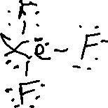

a) trigonal pyramid b) square planar c) It is polar. The trigonal pyramid, with a lone pair on top, and three oxygen “legs” has two different centers of charge.

III. a PF3 is exactly the same as XeO3.. PF5 has 5 fluorines around the P, with no lone pairs on the P. PF3 is trigonal pyramidal, while PF5 is trigonal bipyramid.

b) PF3 is a pyramid with a lone pair on top, and 3 fluorines below – unbalanced charge.

PF5 has balanced charge, with the centers of both + and – charge lying directly in the center of the molecule.

c) Nitrogen is too small to permit 5 electron pairs around it.

d) NaF, because the charges are all the same, but the sodium ions and fluoride ions are smaller than K+ and Cl-, so they are closer together, produceing stronger attractions.

IV. You should have drawn a pyramidal structure just like PF3, but with a 2- charge

1. The oxygens are all -1, and the S is +1. 2) trig. pyramid 3. d. Four electron domains produce a tetrahedral arrangement, but the lone pairs repel the bonding pairs to produce a smaller angle than 109.

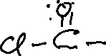

V. ( these were tough.)

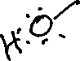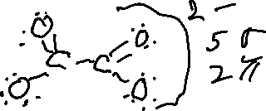

Don’t forget the O-H sigma bond in HNO2