CHAPTER 15 PRACTICE QUIZ Name

MULTIPLE CHOICE – NO CALCULATOR ALLOWED

N2O5(g) 2 NO2(g) + ½ O2(g)

- The equilibrium constant for the gas phase reaction above is 95 at 25oC. What is the value of the equilibrium constant for the following reaction at 25oC?
O2(g) + 4 NO2(g) 2 N2O5(g)

(A) (95)2 (B) (95)½ C) 1/95

(D)
1

952

Questions 2 – 5 refer to the following.

PCl5(g) PCl3(g) + Cl2(g)

PCl5(g) decomposes into PCl3(g) and Cl2(g) according to the equation above. A pure sample of PCl5(g) is placed in a rigid, evacuated 1.00 L container. The initial pressure of the PCl5(g) is
1.00 atm. The temperature is held constant until the PCl5(g) reaches equilibrium with its decomposition products. The figures below show the initial and equilibrium conditions of the system.

PCl5
Ptotal = 1.00 atm

PCl5, PCl3, and Cl2 Ptotal = 1.40 atm

Figure 1: Initial Figure 2: Equilibrium

- As the reaction progresses toward equilibrium, the rate of the forward reaction
  - increases until it becomes the same as the reverse reaction rate at equilibrium
B) stays constant before and after equilibrium is reached
C) decreases to become a constant nonzero rate at equilibrium
D) decreases to become zero at equilibrium

- Which of the following statements about K_{p}, the equilibrium constant for the reaction, is correct? A) K_{p} > 1 B) K_{p} < 1 C) K_{p} = 1
D) It cannot be determined whether K_{p} > 1, K_{p} < 1, or K_{p} = 1 without additional information.

4. A mixture of PCl5(g), PCl3(g), and Cl2(g) is in a 1.00 L reaction vessel. The total pressure of the reaction system is 1.40 atm at equilibrium. Then the volume of the reaction vessel is reduced from 1.00 L to 0.50 L and equilibrium is re-established at constant temperature. What is the total pressure of the system at this point? A) Less than 1.40 atm
B) Greater than 1.40 atm but less than 2.80 atm C) 2.80 atm
D) Greater than 2.80 atm

5. Additional Cl2(g) is injected into the system at equilibrium. Which of the following graphs best shows the rate of the reverse reaction as a function of time? (Assume that the time for injection and mixing of the additional Cl2(g) is negligible.)
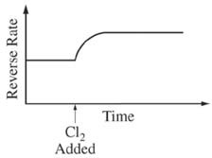
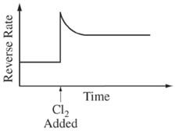
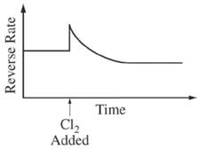
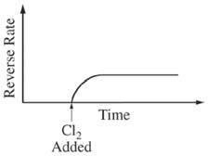
A) B) C) D)

Questions 6 – 7 refer to the following.

N2(g) + 3 H2(g) 2 NH3(g) ΔH < 0

6) NH3(g) was synthesized at 200oC in the presence of a powdered Os(s) catalyst, leading to the equilibrium system represented above. Which of the following changes would result in more NH3(g) in the mixture after equilibrium is re-established?

  - Replacing the powdered Os(s) with a solid cube of Os(s) of the same total mass
  - Increasing the temperature of the system to 250oC at constant pressure
  - Removing some H2(g) D) Adding some N2(g)

7) In a separate experiment, the system is allowed to reach equilibrium at 200oC. Then additional H2(g) is added to reaction vessel. Which of the following will most likely occur as the system approaches equilibrium at constant temperature?

A) [N₂] will increase, and K_{c} will decrease. B) [N₂] will decrease, and K_{c} will increase.
C) [N₂] will decrease, but K_{c} will remain constant. D) [N₂] will increase, but K_{c} will remain constant.
A2(g) + B2(g) 2 AB(g)

8.In a certain experiment, 4.00 mol each of A2(g) and B2(g) are placed in a 1.00 L vessel and allowed to react at constant temperature according to the equation above. Once equilibrium is reached for the reaction mixture, it is determined that the concentration of AB(g) is equal to
2.0 M. What is the value of the equilibrium constant, K_{c} ?
A) 2/9 B) 4/9 C) 0.50 D) 1.0

H2(g) + I2(g) 2 HI(g) Kc = 50. @ 450oC

9. At 450oC, 2.0 moles each of H2(g), I2(g), and HI(g) are combined in a 1.0 L rigid container. Which of the following will occur as the system moves toward equilibrium?

A) More H2(g) and I2(g) will form. B) More HI(g) will form.
C) The total pressure will decrease.
D) No net reaction will occur because the number of molecules is the same on both sides of the equation.
CO(g) + H₂O(g) CO₂(g) + H₂(g) K_{c} = 1.5 x 103

10. A 2.0 mol sample of CO(g) and a 2.0 mol sample of H2O(g) are introduced into a previously evacuated 100. L rigid container, and the temperature is held constant as the reaction represented above reaches equilibrium. Which of the following is true at equilibrium?

(A) [H2O] > [CO] and [CO2] > [H2] (B) [H2O] > [H2]
C) [CO2] > [CO] (D) [CO] = [H2O] = [CO2] = [H2]

2 XY(g) X₂(g) + Y₂(g) K_{p} = 150 @ 500 K

11. A certain gas, XY(g), decomposes as represented by the equation above. A sample of each of the three gases is put in a previously evacuated rigid container. The initial partial pressures of the gases are shown in the table below.

Gas | Initial Partial Pressure (atm)
XY | 0.10
X2 | 2.0
Y2 | 2.0

The temperature of the reaction mixture is held constant at 500 K. In which direction, if any, will the reaction proceed?

A) The reaction will form more products X2 and Y2.
B)The reaction will form more reactant XY.
C) The mixture is at equilibrium, so there will be no change in the partial pressure of any gas.
D) The direction cannot be determined unless the volume of the container is known.
12. Which of the systems in equilibrium represented below will exhibit a shift to the left (toward reactants) when the pressure on the system is increased by reducing the volume of the system? (Assume that temperature is constant.)

(A) SF4(g) + F2(g) SF6(g)

B) H2(g) + Br2(g) 2 HBr(g)

C) CaF2(s) Ca2+(aq) + 2 F–(aq)

  - SO2Cl2(g) SO2(g) + Cl2(g)

FREE RESPONSE – CALCULATOR IS ALLOWED

- In a study of the decomposition of calcium carbonate, a student added a 50.0 g sample of powdered calcium carbonate to a 1.00 L rigid container. The student sealed the container, pumped out all the gases, then heated the container in an oven at 1100 K. As the container was heated, the total pressure of the carbon dioxide gas in the container was measured over time. The data are plotted in the graph below.

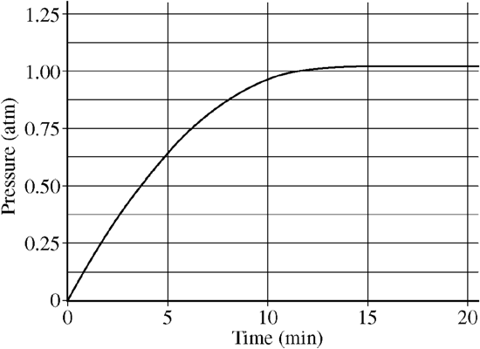

  - Write a balanced equation for the decomposition of calcium carbonate. The products are calcium oxide and carbon dioxide. Include symbols for phases of matter.
  - The pressure in the container after 20 minutes of heating is equal to 1.04 atm.
Calculate the number of moles of carbon dioxide gas present in the container at this point.

(c) The student repeated the experiment, but this time the student used a 100.0 g sample of powdered calcium carbonate. In this experiment, the final pressure in the container was
1.04 atm, which was the same final pressure as in the first experiment.
The student claimed that the final pressure in the container became constant during each experiment because all of the calcium carbonate had decomposed. Based on the data from these two experiments, do you agree with this claim? Explain

(d) Write the expression for the equilibrium constant, K_{p}, for the decomposition of calcium carbonate at 1100 K.
( e) What is the value of K_{p} for this reaction at 1100 K?

(f) After 20 minutes, additional carbon dioxide gas was injected into the container, initially raising the pressure to 1.5 atm. After 20 additional minutes at 1100 K, the final pressure in the container was recorded. Would the final pressure inside the container be less than, greater than, or equal to 1.04 atm? Explain your reasoning.

2. Carbonyl fluoride, COF2, can be prepared by the following reaction:

CO2(g) + CF4(g) 2 COF2(g)

When the system represented above has reached equilibrium at 500oC, the partial pressures of each gas are as follows. PCO2 = PCF4 = 0.50 atm; PCOF2 = 0.35 atm

  - Write the expression for the equilibrium constant, K_{p}, for this system.
  - The value of K_{p} at 500oC is equal to

  - In a certain experiment, CO2(g) and CF4(g) are added to a rigid, previously evacuated reaction vessel. The partial pressures of CO2(g) and CF4(g) are each 3.00 atm. Calculate the partial pressures of all three gases when equilibrium has been reached at 500oC.

  - In another experiment, all three gases CO2(g), CF4(g), and COF2(g) are added to a rigid, previously evacuated reaction vessel. The partial pressures of each gas is equal to 1.00 atm. Calculate the partial pressures of all three gases when equilibrium has been reached at 500oC.

(e) Suppose that additional CO2(g) is added to the reaction vessel after the system has reached equilibrium at 500oC. Determine if each of the following quantities will increase, decrease, or remain the same as the system reestablishes equilibrium at 500oC. Justify your prediction in each case.

  - The partial pressure of CF4
  - The partial pressure of COF₂
  - The equilibrium constant, K_{p}

Ba2+(aq) + EDTA4–(aq) Ba(EDTA)2–(aq) K = 7.7 x 107

- The polyatomic ion C10H12N2O84– is commonly abbreviated as EDTA4–. The ion can form complexes with metal ions in aqueous solutions. A complex of EDTA4– with the Ba2+ ion forms according to the equation above. A 50.0 mL volume of a solution that has an EDTA4–(aq) concentration of 0.30 M is mixed with 50.0 mL of 0.20 M Ba(NO3)2 to produce 100.0 mL of solution.

- Considering the value of K for the reaction, determine the concentration of Ba(EDTA)2–(aq) in the 100.0 mL of solution. Justify your answer.

- The solution is diluted with distilled water to a total volume of 1.00 L. After equilibrium has been re-established, is the number of moles of Ba2+(aq) present in the solution greater than, less than, or equal to the number of moles of Ba2+(aq) present in the original solution before it was diluted? Justify your answer. You should compare Q vs. K in your answer.

