labq Name

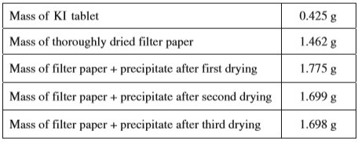
1.

A student is given the task of determining the I- content of tablets that contain KI and an inert, water- soluble sugar as a filler. A tablet is dissolved in 50.0 mL of distilled water, and an excess of 0.20 M Pb(NO3)2(aq) is added to the solution. A yellow precipitate forms, which is then filtered, washed, and dried. The data from the experiment are shown in the table above.

- For the chemical reaction that occurs when the precipitate forms,
  - write a balanced, net-ionic equation for the reaction, and
  - explain why the reaction is best represented by a net-ionic equation.
- Explain the purpose of drying and weighing the filter paper with the precipitate three times.
- In the filtrate solution, is [K+] greater than, less than, or equal to [NO₃⁻] ? Justify your answer.
- Calculate the number of moles of precipitate that is produced in the experiment.
- Calculate the mass percent of I- in the tablet.
- In another trial, the student dissolves a tablet in 55.0 mL of water instead of 50.0 mL of water. Predict whether the experimentally determined mass percent of I− will be greater than, less than, or equal to the amount calculated in part (e). Justify your answer.
- A student in another lab also wants to determine the I− content of a KI tablet but does not have access to Pb(NO₃)₂ . However, the student does have access to 0.20 M AgNO₃ , which reacts with I− (aq) to produce AgI(s). The value of Ksp for AgI is 8.5 x 10−17.
  - Will the substitution of AgNO₃ for Pb(NO₃)₂ result in the precipitation of the I− ion from solution? Justify your answer. Ksp is a very low number which means AgI is almost insoluble, so it WILL precipitate. We learn about Ksp in April!
  - The student only has access to one KI tablet and a balance that can measure to the nearest
0.01 g. Will the student be able to determine the mass of AgI produced to three significant figures? Justify your answer.

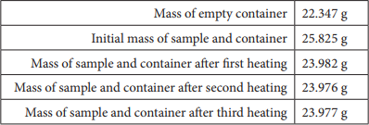
- Answer the following questions relating to gravimetric analysis.

In the first of two experiments, a student is assigned the task of determining the number of moles of water in one mole of MgCl2 ⋅ n H2O. The student collects the data shown in the following table.

  - Explain why the student can correctly conclude that the hydrate was heated a sufficient number of times in the experiment.

  - Use the data above to
- calculate the total number of moles of water lost when the sample was heated, and
- determine the formula of the hydrated compound.

  - A different student heats the hydrate in an uncovered crucible, and some of the solid spatters out of the crucible. This spattering will have what effect on the calculated mass of the water lost by the hydrate? Justify your answer.

In the second experiment, a student is given 2.94 g of a mixture containing anhydrous MgCl2 and KNO3
. To determine the percentage by mass of MgCl2 in the mixture, the student uses excess AgNO3(aq) to precipitate the chloride ion as AgCl(s).

  - Starting with the 2.94 g sample of the mixture dissolved in water, briefly describe the steps necessary to quantitatively determine the mass of the AgCl precipitate.

  - The student determines the mass of the AgCl precipitate to be 5.48 g. On the basis of this information, calculate each of the following.

    - The number of moles of MgCl2 in the original mixture
    - The percent by mass of MgCl2 in the original mixture

