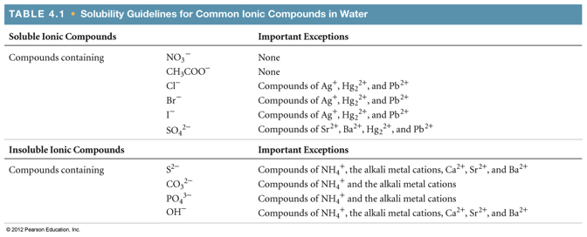

Additional note: Compounds containing alkali metal ions (group 1) or the ammonium ion are always soluble.

Chromates, CrO42− follow the same solubility rules as sulfates, SO42−