Chemistry Final, fall 2018

YOU MAY NOT USE YOUR CALCULATOR FOR SECTION I

1. A 1.00 gram sample of which of the following compounds contains the greatest mass of nitrogen? A) NO B) N₂O₃ C) N₂H₄ D) N₂

 | Nitrogen | Oxygen
First Ionization Energy (kJ/mol) | 1400 | 1300
Covalent Atomic Radius (pm) | 70 | 66
Electronegativity | 3.0 | 3.5

Base your answers to questions 2 to 4 on the information in the table above.

2. The lower first ionization energy of oxygen, compared with that of nitrogen is best explained by A) a greater effective charge acting on the valence electrons in oxygen
B) repulsions between the electrons in the filled “p” orbital of an oxygen atom
C) repulsions between 2s and 2p electrons that are greater in oxygen than in nitrogen
D) a greater effective charge acting on the valence electrons in nitrogen

3. Which description most accurately describes the nitrogen and oxygen atoms in a molecule of nitrogen monoxide, NO?
A) The nitrogen acquires a charge of 2+, while the oxygen acquires a charge of 2- B) The nitrogen acquires a slight + charge, while the oxygen acquires a slight - charge C) The nitrogen acquires a slight - charge, while the oxygen acquires a slight + charge D) Both atoms remain electrically neutral due to nonpolar covalent bonding

4. Compared with the data for these two elements, we would expect the ionization energy, atomic radius, and electronegativity values for fluorine, to be, respectively
A) larger, smaller, larger C) smaller, larger, smaller
B) larger, larger, larger D) smaller, smaller, larger

Questions 5 -9 refer to the following molecules:

A) CH₂Cl₂ B) ICl₃ C) CBr₄ D) SO₃

5. Which molecule is both a dipole and has tetrahedral geometry?
A) A B) B C) C D) none of these

6. Which molecule(s) have a planar molecular geometry?
A) A and D B) A and B C) B and D D) D only

7. In which molecule are the bond angles closest to 90̊ ?
A) A B) B C) C D)D
8. In which molecule does the central atom contain non-bonding electron pairs (lone pairs)?
A) A B) B C) C D) D

9. Which molecule contains both sigma and pi bonds?
A) A B) B C) C D) D

10. A yellow solid melts at 700°C, and does not conduct electricity. However, when melted or when dissolved in water it does conduct electricity. Which of the following could be the
identity of that solid? A) urea (CO(NH₂)₂ B) gold C) sodium chromate, Na₂CrO₄
D) silicon dioxide, SiO₂

11. The CF₄ molecule is nonpolar, while the SF₄ molecule is polar. Which statement best accounts for this difference in molecular polarity?
A) CF₄ contains only σ bonds, while SF₄ contains both σ and π bonds.
B) S-F bonds are polar, while C-F bonds are nonpolar
C) C-F bonds have more ionic character than S-F bonds
D) CF₄ has a symmetrical charge distribution, with no lone pairs on the central atom,
while SF₄ has an asymmetric charge distribution, with a lone pair on the central atom

12. The enthalpy of vaporization of ethane, C₂H₆ is 14.7 kJ/mol, while that of water is 40.7
kJ/mol. The best explanation of the higher value for water is that
A) ethane does not exhibit hydrogen bonding, while water does
B) the larger ethane molecules are more highly polarizable than the smaller water molecules
C) ethane has a smaller density than water
D) the O-H bonds in water have a higher bond energy than to the C-H bonds in ethan

13. At STP, the volume of 1.00 mole of O₂, N₂, or He gas is 22.4 liters. However, the volume of 1.00 mole of SO₂ gas at STP is 21.9 liters. The best explanation of the smaller volume occupied by the SO₂ molecules is
A) the larger SO₂ molecules cannot be treated as point sources, and occupy a significant portion of the container.
B) the larger SO₂ molecules move slower than the other gas particles, and therefore exert a smaller pressure on the container walls.
C) there are significant intermolecular attractions between SO₂ molecules.
D) endothermic collisions between SO₂ molecules decrease the average molecular velocity.

14. A sample of O₂ gas occupies a volume of 20.0 liters. If the number of moles of oxygen, the pressure of the oxygen, and the Kelvin temperature of the oxygen are ALL doubled, the new volume of the oxygen will be
A) 20.0 liters B) 40.0 liters C) 60.0 liters D) 160. liters

Base your answers to questions 15-16 on the following :
CO_{(g)} is added to a reaction vessel until the pressure is 2.0 atmospheres. H_{2(g)} is added until the total pressure reaches 5.0 atmospheres. The reaction CO_{(g)} + 2 H_{2(g)} ➞ CH₃OH _{(g)} occurs, and reaches equilibrium at a total pressure of 3.0 atm. The temperature is kept constant.

15. What is the initial pressure of the hydrogen gas, before the reaction takes place?
A) 2.0 atm B) 3.0 atm C) 5.0 atm D) 7.0 atm

16. What is the pressure of the hydrogen gas at equilibrium?
A) 1.0 atm B) 0.020 atm C) 25atm D) 50 atm

17. How many moles of ZnCl₂ would be needed to produce a [Cl– ] of
0.100 molar in a volume of 100. mL ?
A) 5.00x10⁻³ B) 1.00 x 10⁻² C) 2.00 x 10⁻² D) 20.0

18. Which sentence correctly describes and explains the differences in first ionization energy
between F and Ne?
A) Fluorine has a higher ionization energy because of its greater electronegativity
B) Fluorine has a higher ionization energy because of its higher electron affinity
C) Neon has a higher ionization energy because of its greater nuclear charge
D) Neon has a higher ionization energy because of its completely filled 2p sublevel

19. What are the signs of ΔHº and ΔSº for a reaction that is spontaneous only at low temperature? A) ΔHº is positive, ΔSº is positive B) ΔHº is negative, ΔSº is positive
C) ΔHº is positive, ΔSº is negative D) ΔHº is negative, ΔSº is negative

20. According to the equation, N₂O_{3(g)} + 6 H_{2(g)} ➞ 2 NH_{3(g)} + 3 H₂O_{(g)}, how many moles
of NH_{3(g)} could be formed from the reaction of 0.22 mol of N₂O₃ with 0.90 moles
of H₂? A) 0.30 B) 0.45 C) 0.60 D) 1.2

21. 50.0 mL of 2.00 molar NaNO₃ is mixed with 20.0 mLof 3.00 molar KNO₃. The solution is diluted with water to a final volume of 100. mL. What is the concentration of NO₃⁻ in the solution? A) 1.60 M B) 0.160 M C) 16.0 M D) 0.150 M

22. The O—N—O bond angle in the nitrite ion, NO₂– is closest to
A) 180̊ B) 120̊ C) 90 ̊ D) 109̊

23. In which species is the electron geometry around the central atom tetrahedral?
A) SF₄ B) BF₄– C) XeF₄ D) PCl₅

24. Which process requires the greatest amount of energy per mole of H₂O ?
A) breaking the O–H bonds C) subliming the solid
B) evaporating the liquid D) melting the solid

25. Given these reactions: A ➞ 2 B ΔHº = +30 kJ
B➞C ΔHº = -60 kJ
2C ➞ D ΔHº = -20 kJ
Calculate ΔHº for the reaction D + A ➞ 4 C
A) –70 Kj B) –110 Kj C) –190 kJ D) + 110 Kj

26. Which of the following Lewis dot diagrams represents the molecule that is the most highly polar?

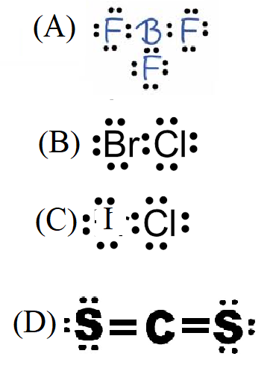

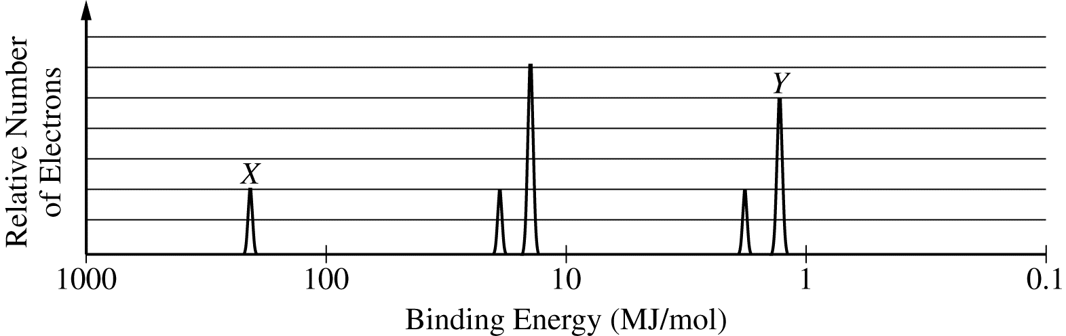

27. The peak labelled "Y" corresponds to a certain orbital in Cl. How would the peak for the SAME orbital in a SULFUR atom compare with peak "Y" , if drawn on the same axes?
A) the peak would be shorter, and to the left of peak Y.
B) the peak would be taller, and to the let of peak Y.
C) the peak would be shorter and to the right of peak Y
D) the peak would be taller, and to the right of peak Y.

28. Four hydrocarbons are analyzed, and found to have the masses of C and H shown below.
Hydrocarbon A: 30.0g of C and 2.50 g of H. B: 60.0 g of C and 10.0 g of H
C) 6.0 g of C and 1.5 g of H. D) 24.0 g of C and 1.60 g of H

29. A 2.50 L sample of a gas is found to have a lower pressure than that predicted by solving for P in the equation P = nRT/V. The most probable explanation of this observation is
A) the gas particles occupy a significant portion of the volume of the container.
B) the gas particles have a small mass, and so exert a smaller force on the container walls
C) there are significant attractions between the gas particles and the container walls
D) there are significant attractions among the gas particles, causing them to strike the container walls less frequently.

30. A balloon filled with 0.50 mole of helium, initially at 101.3 kPa, and 298 K rises to a much higher elevation. What happens to the volume of the balloon as it moves to a height where the air temperature is 240 K, and the air pressure is 0.20 atm?
A) The volume will decrease because the effect of decreased temperature will be greater than the effect of decreased pressure
B) The volume will increase, because the effect of decreased pressure will be greater than the effect of decreased temperature
C) The volume will remain the same, since one factor would increase it, while the other would decrease it
D) The direction of the volume change cannot be predicted without knowing the initial volume of the balloon.

31. An inflated rubber balloon will eventually decrease in volume because gas molecules can escape through small openings in the rubber. Two balloons are inflated to a volume of 20.0 liters. One contains He gas, and the other contains N₂ gas. Which gas will escape from the balloon faster?
(A) N₂, because its initial pressure in the balloon is greater
(B) N₂ because its heavier molecules have a greater average kinetic energy than the He molecules
(C) He, because the average speed of the He molecules is greater than that of the N₂ molecules
(D) Since both gases are initially at the same temperature, pressure and volume, they will escape at the same rate.

32. In the reaction C₂H₂ + Cl₂ C₂H₂Cl₂ does the hybridization of the carbon atoms change?
(A) Yes, from sp to sp² (B) Yes, from sp² to sp³ (C) Yes, from sp to sp³
(D) No, the hybridization does not change.

33. If equal masses of the following compounds undergo complete combustion, which will yield the greatest mass of CO₂ ? (A) C₂H₂ (B) C₃H₈ (C) C₆H₁₂O₆ D) CH₄

34. When 10.0 g of NH₄ClO₄ is added to 100. mL of water in a calorimeter, the temperature of the solution formed decreases by 6.0° C. If 10.0 g of NH₄ClO₄ is added to 1000. mL of water in a calorimeter initially at 25.0° C, what will be the final temperature of the solution?
A) 19.0° B) 24.4 ° C) 25.6 ° D) 31.0°

35. The SO₃ molecule is nonpolar, while the NF₃ molecule is polar. Which statement best accounts for the difference in polarity?
(A) SO₃ has a planar geometry, while NF₃ has a nonplanar geometry
(B) The electronegativity difference in an S-O bond is smaller than that in an N-F bond
(C) NF₃ is ionic, while SO₃ is covalent
(D) NF₃ has only sigma bonds, while SO₃ has pi bonds.

