Name_______________________________ “A Curve Bawl”

Base your answers to questions 1 to 5 on diagram 1, to the right of this page.
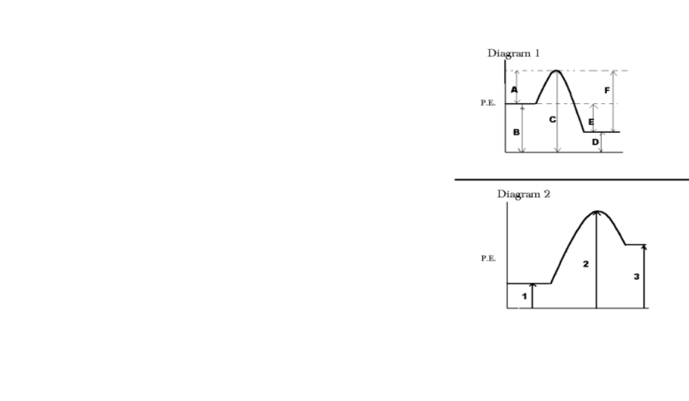
_____1. Which line represents ΔH°, the heat of reaction?

_____2. This reaction is A) endothermic and absorbs heat
B) endothermic and releases heat
C) exothermic, and absorbs heat
D) exothermic, and releases heat

_____3. Which line represents the potential energy of the product?

_____4. If the activation energy of this reaction in the forward
direction is 30.0 kJ/mol, and the reaction has a ΔH of
–40 kJ/mol, what is the activation energy of the reverse
reaction? A) –10 kJ/mol B) 70 kJ/mol
C) 10 kJ/mol D) 80 kJ/mol

_____5. Which of the following lines would be changed by the
addition of a catalyst? A)A B)B D)D E)E
(there is no choice C for this question)

_____6. Which line represents the activation energy of the reverse reaction?
A) A D)D E) E F) F

7-10 are based on diagram 2.

______7. In this reaction, the activation energy of the forward reaction would be a line
that is equivalent to A) line 2 + line 1 B) line 2 - line 1 C) line 2
D) line 3

______8. In this diagram, line 3 minus line 1 would represent the
A) heat of reaction B) forward activation energy C) reverse activation energy
D) potential energy of the reactant.

______9. Line 2 in this diagram represents A) the potential energy of the product
B) the activation energy of an endothermic reaction
C) the potential energy of the activated complex
D) the heat of reaction of the reverse reaction

______10. Which reaction might produce the potential energy diagram shown in diagram 2?
A) Aluminum reacts with oxygen to form aluminum oxide B) nitrogen reacts with oxygen to produce nitrogen dioxide C) carbon reacts with oxygen to produce carbon dioxide D) nitrogen reacts with hydrogen to produce ammonia

_____11.A student wished to speed up the reaction Mg(s) + 2 HCl(aq) ➞ MgCl₂ + H₂ so
she added some hot water to the flask containing the Mg and HCl(aq). She was surprised when the reaction actually got slower. This was because by adding water she
A) decreased the temperature of the system B) increased the temperature of the system C) decreased the concentration of the acid
D) increased the concentration of the acid.

____12. A reaction between the gases SO₂ and O₂ will become slower if you increase the
A) volume of the container B) temperature C) pressure of SO₂ D) pressure of O₂

_____13. As the average kinetic energies of the reacting chemicals increase, the rate of the reaction between them A) decreases B) increases C) stays the same

______14. As NaCl is added to pure water, the freezing point of the water
A) increases, and the boiling point increases
B) increases, and the boiling point decreases
C) decreases, and the boiling point increases
D) decreases, and the boiling point decreases

______15. Which 1.0 molar solution in water is likely to have the lowest freezing point?
A) FeCl₃ B) NaCl C) Na₂SO₄ D) C₆H₁₂O₆

______16. How many grams of KNO₃ will form a saturated solution in 50.0 grams of water at a
temperature of 32°C?

______17. A saturated solution of KCl in 100 g of water is prepared at 10°C. The solution is then heated to 90°C. How many additional grams of KCl must be added to make the solution saturated?

______18. 50.0 mL of a 6.00 molar NaOH solution is diluted with water to a new total volume of 400. mL. What is the new molarity of the NaOH solution? A) 48.0 M
B) 0.750 M C) 8.00 M D) 1.25 M

______19. A sample of contaminated water with a mass of 2000 grams is found to contain 0.100 grams of Pb²⁺ ion. What is the concentration of the lead ion in parts per million?
A) 50 ppm B) 500 ppm C) 100 ppm D) 20 ppm

20. A student wishes to prepare a 2.00 molar solution of KNO₃ using a 10.1 gram sample of KNO₃. If the entire sample is used, what must be the final volume of the solution?
Show work.

Answers 1 E 2 D 3 D 4. B 5. A 6. F 7. B 8. A 9. C 10. B (use table I)
11.C 12 A 13. B 14. C 15. A 16. 25 g 17. 24 g 18. B 19. A 20. 50. mL

