- The respective hybridizations of nitrogen and phosphorous in NH3 and PF3, respectively, are
  - sp2 and sp2
  - sp2 and sp3
  - sp and sp3
  - sp3 and sp3

H2O | O-H | 96
H2S | S-H | 134
- Based on the information given in the table above, which statement best explains why S-H bond length is longer than O-H bond length?
  - The S atom has a larger atomic radius making the Coulombic attractions weaker and the bond length longer.
  - The S atom has a larger atomic radius making the Coulombic attractions stronger and the bond length longer.
  - The S atom has a smaller atomic radius making the Coulombic attractions weaker and the bond length longer.
  - The S atom has a smaller atomic radius making the Coulombic attractions stronger and the bond length longer.

- How many sigma (σ) and pi (π) bonds are in C2H2 in which the two carbon atoms are adjacent and each carbon atom has one hydrogen atom attached to it?
  - Three sigma and two pi bonds
  - Four sigma and one pi bond
  - Three sigma and one pi bond
  - One sigma and one pi bond

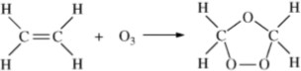

- In the reaction represented above, what is the hybridization of the C atoms before and after the reaction occurs?
(A) Before = sp After = sp2
- Before = sp After = sp3
- Before = sp2 After = sp
(D) Before = sp2 After = sp3

- According to the VSEPR model, the progressive decrease in the bond angles of the central atom of the molecules CH4, NH3, and H2O, is best accounted for by
  - Decreasing size of the central atom.
  - Increasing electronegativity of the central atom.
  - Increasing number of unshared pairs of electrons.
  - Decreasing repulsion between hydrogen atoms.

- The Lewis dot structure of an amino acid is shown below.
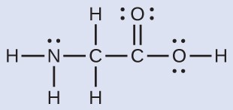
What is the total number of sigma (σ) and total number of pi (π) bonds in the entire molecule.
  - Fourteen sigma bonds and one pi bond
  - Seven sigma bonds and one pi bond
  - Eight sigma bonds and two pi bond
  - Nine sigma bonds and one pi bond

- The H-O-H bond angle in H2O is less than the H-C-H bond angle in CH4 due to
  - Pairs of unbonded electrons in water
  - Repulsion between hydrogen atoms in water
  - Attraction between hydrogen atoms in water
  - Tetrahedral shape of water

- A chemist analyzed the bond between carbons in C2H6 and found that it had a bond energy of 348kJ/mol and a bond length of 154 pm. If the chemist performed the same analysis on the bond between the carbons in C2H4 how would the results compare?
  - The bond energies for C2H4 would be smaller, and the bond length would be shorter.
  - The bond energies for C2H4 would be greater, and the bond length would be longer.
  - The bond energies for C2H4 would be smaller, and the bond length would be longer.
  - The bond energies for C2H4 would be greater, and the bond length would be shorter.

- Given a molecule with the general formula XY2, which one of the following would be the most useful in determining whether the molecule was linear or bent?
  - Dipole moments
  - Electron affinities
  - Bond energies
  - Electronegativities

Questions 10-11 refer to the information below.
The diagram below shows a Potential Energy vs. Internuclear Distance plot for the formation of a diatomic molecule, X2.
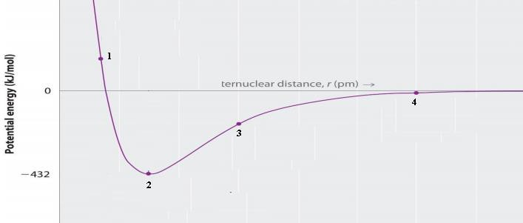

- When the two atoms of X that make up the diatomic molecule approaches the Internuclear distance of Point 2,
  - Maximum stability is achieved as a covalent bond is formed and 432 kJ/mole of energy is released.
  - Minimum stability is achieved as a covalent bond is formed and 432 kJ/mole of energy is released.
  - Maximum stability is achieved as a covalent bond is formed and 864 kJ/mole of energy is released.
  - Minimum stability is achieved as a covalent bond is formed and 864 kJ/mole of energy is released.

- Which best describes the electrostatic forces in X2 at Point 1?
  - Repulsive forces and attractive forces are equal.
  - Attractive forces are the predominant forces.
  - Repulsive forces are the predominant forces.
  - The two atoms do not experience any electrostatic forces.

Questions 12 refers to the reactions represented below, which are involved in a demonstration commonly known as “underwater fireworks.”
Reaction 1: CaC2 (s) + 2 H2O (l) → C2H2 (g) + Ca(OH)2 (s) Reaction 2: NaOCl (aq) + 2 HCl (aq) → Cl2 (g) + NaCl (aq) + H2O (l) Reaction 3: C2H2 (g) + Cl2 (g) → C2H2Cl2 (g)
- When Reaction 3 occurs, does the hybridization of the carbon atoms change?
  - Yes; it changes from sp to sp2.
  - Yes; it changes from sp to sp3.
  - Yes; it changes from sp2 to sp3.
  - No; it does not change.
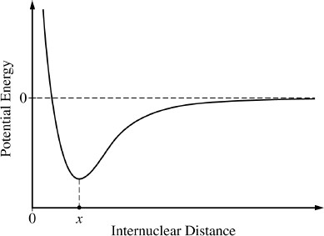
- The potential energy of a system of two atoms as a function of their internuclear distance is shown in the diagram above. Which of the following is true regarding the forces between the atoms when their internuclear distance is x?
  - The attractive and repulsive forces are balanced, so the atoms will maintain an average internuclear distance, x.
  - There is a net repulsive force pushing the atoms apart, so the atoms will move further apart.
  - There is a net attractive force pulling the atoms together, so the atoms will move closer.
  - It cannot be determined whether the forces between atoms are balanced, attractive, or repulsive, because the diagram shows only the potential energy.

- The BF3 molecule is nonpolar, whereas the NF3 molecule polar. Which of the following statements accounts for the difference in polarity of the two molecules?
  - In NF3 each F is joined to N with multiple bonds, whereas in BF3, each F is joined to B with single bonds.
  - N-F bonds are polar, whereas B-F bonds are nonpolar.
  - NF3 is an ionic compound, whereas BF3 is a molecular compound.
  - Unlike BF3, NF3 has a nonplanar geometry due to an unshared pair of electrons on the N atom.

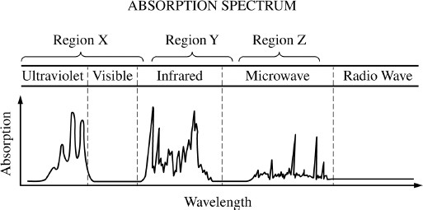

- The diagram above represents the absorption spectrum for a pure molecular substance. Which of the following correctly indicates the type of transition observed for the substance in each of the regions of the electromagnetic spectrum?
Region X | Region Y | Region Z
(A) Molecular Vibration | Molecular rotation | Electronic transition
(B) Electronic transition | Molecular rotation | Molecular vibration
(C) Molecular rotation | Molecular vibration | Electronic transition
(D) Electronic transition | Molecular vibration | Molecular rotation
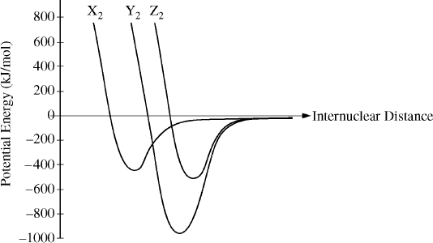

- The potential energy as a function of internuclear distance for three diatomic molecules, X2, Y2, and Z2, is shown in the graph above. Based on the data in the graph, which of the following correctly identifies the diatomic molecules, X2, Y2, and Z2?
X2 Y2 Z2
  - H2 N2 O2
  - H2 O2 N2
  - N2 O2 H2
  - O2 H2 N2

- Lewis electron-dot diagrams for CO2 and SO2 are given above. The molecular geometry and polarity of the two substances are
  - The same because the molecular formulas are the same.
  - The same because C and S have similar electronegativity values
  - Different because the lone pair of electrons on the S atom make it the negative end of a dipole
  - Different because S has a greater number of electron domains (regions of electron density) surrounding it than C has

- What is the best explanation of why a molecule with the structure of NBr5 cannot exist?
  - Nitrogen only has two energy levels and is thus unable to expand its octet.
  - Bromine is much larger than nitrogen and cannot be a terminal atom in this molecule.
  - It is impossible to complete the octets for all six atoms using only valence electrons.
  - Nitrogen does not have a low enough electronegativity to be the central atom of this molecule.

- The six carbon atoms in a benzene molecule are shown in different resonance forms as three single bonds and three double bonds. If the length of a single carbon-carbon bond is 154 pm and the length of a double carbon-carbon bond is 133 pm, what length would be expected for the carbon-carbon bonds in benzene?
  - 126 pm
  - 133 pm
  - 140 pm
  - 154 pm

- Which of the following Lewis electron-dot diagrams represents the molecule that contains the smallest bond angle?

